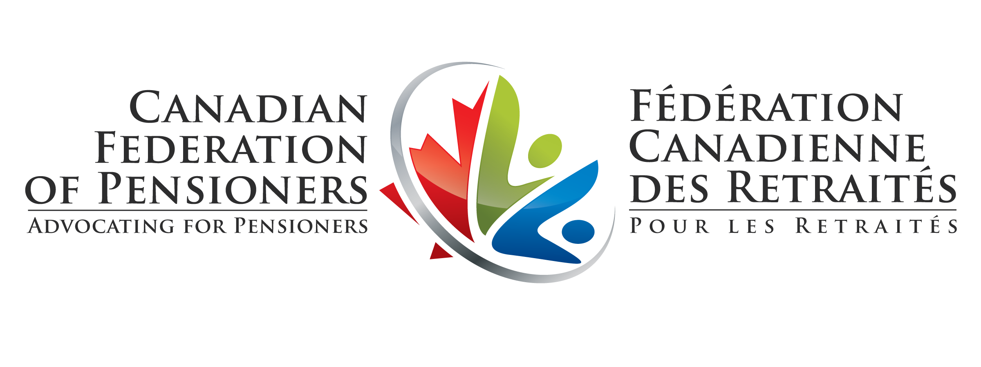

Comments
of the
Canadian Federation of Pensioners
on
Reform of Ontario’s Funding Rules for Defined Benefit Pension Plans:
Description of New Funding Rules

Proposal Number: 17-MOF018

29 January 2018

Draft: 15 Jan 2018

The Canadian Federation of Pensioners (CFP) provides its comments on the proposed regulations relating to the new funding framework for defined benefit pension plans announced by the government on May 19, 2017.
In the course of the consultation on pension reform, CFP has commented many times on the form that pension reform should take. CFP will not repeat those arguments here. Rather, CFP limits its comments to those issues that are the most harmful to active and retired members of defined benefit pension plans in Ontario.
Regarding solvency funding, CFP has accepted that the solvency funding target can be lowered from 100%, but only on the condition that the Pension Benefits Guarantee Fund would be capable of making good on any windup shortfalls for plans terminating involuntarily. Though the regulations lower the solvency funding target to 85%, the legislative changes in Bill 177 fall well short of the condition proposed by CFP. As a result, some pensioners will suffer greater loss of pension than they would have had the rules not been changed. This outcome is frustrating to CFP, as full protection could be provided to pensioners at no cost to taxpayers, while providing significant savings to DB employers.
Regarding going concern funding, regulations are purported to strengthen the funding rules. But those regulations achieve the opposite. In particular, the government has announced that the new rules will lower the allowed amortization of going concern deficits from 15 years to 10 years. But the regulations do no such thing. Those rules extend the duration of going concern deficits, not shorten it.
Solvency Funding and the PBGF
The most recent report of the Financial Services Commission of Ontario on the funding status of defined benefit pension plans shows that private sector DB plans are, on average, underfunded by 22%. That is, even when the rules insist on a solvency funding target of 100%, actual plan funding falls well short. The new rules lower the target from 100% to 85%, and make no other changes that would have the effect of lowering plan deficits. Lowering the funding target can have only one reasonable outcome: the funding status of DB plans will worsen as a result of the government’s regulatory changes.
Acknowledging that pensioner risk is increased when funding targets are lowered, the new regulatory regime increased the coverage of the Pension Benefits Guarantee Fund (PBGF) from $1000 to $1500. That means that any pensioner with an annual pension in excess of $18000/year will feel the full brunt of plan underfunding for pension amounts over $18000.
Though the PBGF change is characterized as increasing protection by 50%, an accurate interpretation is that, even with the change, PBGF protection is only half of what it was when the PBGF was first introduced in 1980.
The PBGF coverage limit was set at $1000 in 1980, and has been unchanged since. In its report of 2008, the Ontario Expert Commission on Pensions called on the government to increase the PBGF limit so that it could keep pace with inflation. Inflationary increases to the PBGF limit would have seen it reach the $1500 limit three decades ago, in 1987. In real terms, the $1500 PBGF limit provides half the protection to pensioners than the $1000 limit did in 1980.
CFP’s submissions to the government have illustrated how only a small portion, in the order of 5%, of the savings employers will enjoy due to the lowered solvency funding target, would be needed to protect fully all private sector DB pensioners.
If ever there was a “win-win” solution, this is it. Yet the government has refused to adopt it. Now that the regulations pertaining to going concern funding have been clarified, CFP can confirm that its estimate for the savings to be realized by employers has been understated. If a 5/95 split in savings is not compelling (where 5% goes to the PBGF to protect pensioners and 95% goes to employers), would a 3/97 split be more compelling?
CFP once again calls on the government to ensure that regulations:
- Disallow the exclusion of any plan provisions, such as indexation, from the calculation of a plan’s solvency liabilities; and
- Ensure that the PBGF can make good on any windup shortfall of any private sector DB plan that terminates involuntarily.

Going Concern Funding
The myth of reducing the amortization period
The description of the proposed regulations includes “shortening the amortization period from 15 years to 10 years for funding a going concern shortfall in the plan”. It also notes that the framework will be changed by “consolidating going concern special payment requirements into a single schedule when a new report is filed”.
These two statements are at odds with each other. An “amortization period” is a meaningful term only if payments are fixed throughout the period, and the shortfall is eliminated by the end of the period. By contrast, “consolidating going concern special payments” means that scheduled payments are not fixed, they change year by year.
How does Ontario reconcile these contradictory approaches? The answer is made clear in the document that is the subject of these comments. The regulations do not shorten amortization periods. The fact is, consolidating going concern special payments in the manner proposed has the effect of prolonging the duration of going concern deficits, not shortening that period.
The prolonging of the deficits is illustrated by tracking the reduction of a deficit over time, under the old and the proposed rules. Under the old rules, a going concern deficit that arose in a year has to be eliminated over a 15 year period. The following chart (Fig 1) depicts the percentage remaining, in each year following the year in which the deficit arose.

Under the new rules, that same deficit makes up part of the “consolidated” deficit that determines each year’s special payment. Each year’s special payment is calculated assuming a ten year amortization period. But there is no ten year amortization period, because in the following year, payments are recalculated assuming the start of a new ten year amortization period, and so on.
Any homeowner with a mortgage understands that a fixed 25 year amortization period means that equal payments over 25 years will eliminate the original mortgage. What would happen if each year, a new 25 year payment schedule was struck for the remaining principle? When would the mortgage be paid off? Never. Because each year a new 25 year schedule starts; elimination is always 25 years away. The remaining principle and monthly mortgage payments steadily decrease over time, but they never get to zero.
That is what is happening with the going concern funding regulations. Each year it is pretended that a new ten year amortization period begins anew. But it only lasts one year, and then the calculations are done again. Fig 2 contrasts the effects of the old rule, a true 15 year amortization of a deficit, with the new rule that applies to the consolidated deficit and each part of it, including the deficit being tracked for illustration purposes. It can be seen that after ten years, the deficit is not eliminated: 43% remains. After 15 years, 29% remains. It takes some 50 years to get the deficit down to around 1% of the initial amount. Not only do the new rules not shorten the duration of deficits, they extend it significantly.

What is one to conclude? Either the drafters of the regulations have not fully understood the implications of consolidating deficits on the duration of deficits, or there has been an attempt to portray regulatory measures that prolong deficits as measures that would shorten them. The latter is an unsavoury interpretation. It requires one to believe that because the language of a ten year amortization is used in the special payment calculation, it has been decided that it would be appropriate to hoodwink pensioners into believing that amortization periods are actually being lowered from 15 years to 10.
The latter interpretation casts great shame on the government. Therefore, CFP concludes that the regulations as drafted have unintended consequences, and suggests a change to the regulations that will have the effect of delivering what was promised, while retaining the consolidation of deficits. If an amortization of three years is used in the calculation of the special payments, then any deficit arising in a year will be almost eliminated over the following ten years. See Fig 3. That is the outcome promised by the Minister of Finance in his May 19 announcement.

An alternative would be for the regulations to abandon the consolidation of going concern deficits, and instead continue to maintain separate schedules of special payments, each one predicated on a true amortization of 10 years rather than 15 years. Either approach would be consistent with the Minister’s announcement. The draft regulations, as they are described, put a lie to the Minister’s words.
PfAD not applied to indexation
It is stated that “contributions in respect of the PfAD would not be required for either the going concern liabilities or the normal cost in respect of future indexation”. The statement is provided without rationale. The lack of rationale is likely because there is none.
This is an arbitrary exclusion of a plan provision from funding requirements. Plan funding is clearly put at risk if plan provisions need not be funded for regulatory purposes. When provisions are excluded, a plan may appear to be fully funded when it is not. Exclusions not only impose risks on those relying on their pension plan to be fully funded, they also send the wrong signals to regulators who are charged with overseeing the proper functioning of the regulatory regime.
Indexation is currently excluded from the calculation of solvency liabilities. CFP has objected to this treatment for many years, and continues to do so. The FSCO reports on the funding of DB pensions notes that indexation makes up some 10% of total plan liabilities. Not all plans have indexation provisions, so the exclusions amount to a considerably larger proportion of plan liabilities for those plans that provide indexation. The indexation provisions of a pension plan can amount to 25% or 30% of a plan’s liabilities. Excluding them for funding purposes, either in the plan liabilities – as is the case for solvency liabilities - or the application of the PfAD to going concern liabilities undermines the protection that the regulations are intended to effect.

Summary
Consequently, the following changes to the regulations are necessary:
- Disallow the exclusion of any plan provisions, such as indexation, from the calculation of a plan’s solvency liabilities;
- Ensure that the PBGF can make good on any windup shortfall of any private sector DB plan that terminates involuntarily;
- Either retain the consolidation of going concern deficits and calculate the funding requirement premised on a three-year amortization period, or retain separate schedules of going concern special payments, each one premised on a ten year amortization period; and
- Apply the PfAD in respect of all plan provisions, including indexation, for purposes of determining the funding of normal costs and going concern liabilities.

www.ontariocanada.com/registry/view.do?postingld=25526&language=en
For illustration purposes a discount rate of 5%/year and a single fixed payment per year are assumed.
The deficit remaining in year k+1 is equal to the deficit in year k, adjusted for the discount rate, and less the contribution made to retire the deficit. That is, D(k+1)=D(k)*(1+d) – P(k), where d is the discount rate and P(k) is the payment. The payment P(k) is calculated as the amount that would be necessary each year to eliminate D(k) over 10 years, P(k)=d*D(k)*(1+d)**10/((1+d)**10-1). P(k) is not paid each year for 10 years. It is paid once, and then a new P(k+1) is calculated.

